Module - 4
Real world and Virtual world Motions
Motion in Real and Virtual Worlds - Velocities and Accelerations- A one-dimensional world, Motion in a 3D world, The Vestibular System, Physics in the Virtual World – Tailoring the Physics to the Experience, Numerical simulation, Collision detection, Mismatched Motion and Vection.
Motion in Real and Virtual Worlds
The physics of both real and virtual worlds impact VR experiences. The accelerations and velocities of moving bodies impact simulations in the VWG and tracking methods used to capture user motions in the physical world.
- Velocities and Accelerations
1.1 A one-dimensional world
Imagine a 1D world in which motion is only possible in the vertical direction. Let y be the coordinate of a moving point. Its position at any time t is indicated by y(t), meaning that y actually defines a function of time.
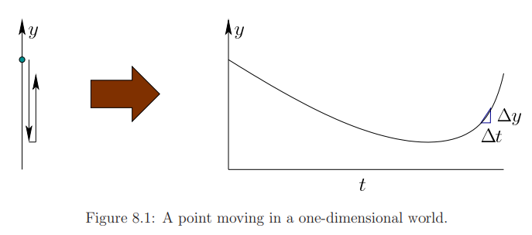
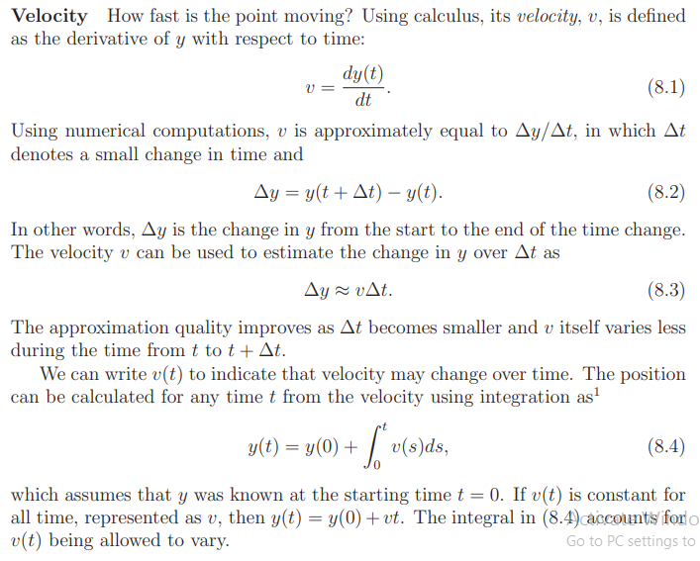
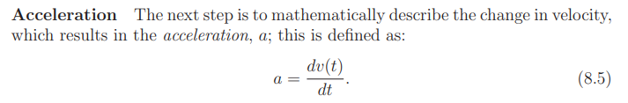
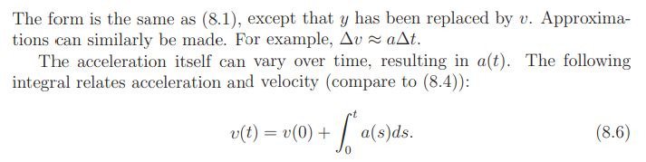
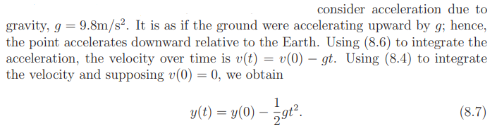
  - Motion in a 3D world
A moving point
Imagine that a geometric model is moving over time. This causes each point (x, y, z) on the model to move, resulting a function of time for each coordinate of each point:
The velocity v and acceleration a must therefore expand to have three coordinates. The velocity v is replaced by (v_{x}, v_{y}, v_{z}) to indicate velocity with respect to the x, y, and z coordinates, respectively. The magnitude of v is called the speed:
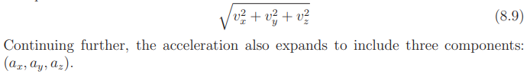
In this case, all its points move together. Translations or rotations are used to describe the motion. First, consider a simple case. Suppose that rotations are prohibited, and the body is only allowed to translate through space. In this limited setting, knowing the position over time for one point on the body is sufficient for easily determining the positions of all points on the body over time. If one point has changed its position by some (x_{t}, y_{t}, z_{t}), then all points have changed by the same amount. More importantly, the velocity and acceleration of every point would be identical.
Once rotation is allowed, this simple behavior breaks. As a body rotates, the points no longer maintain the same velocities and accelerations. This becomes crucial to understanding VR sickness and how tracking methods estimate positions and orientations from sensors embedded in the world.
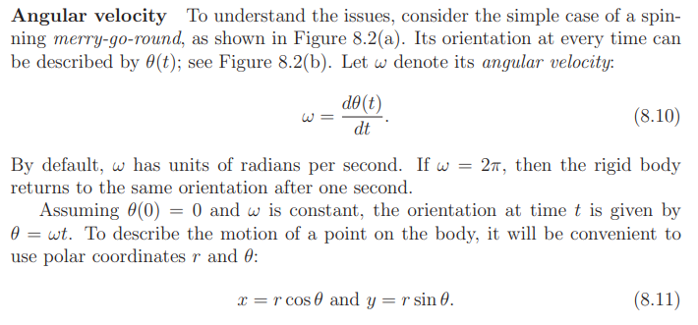
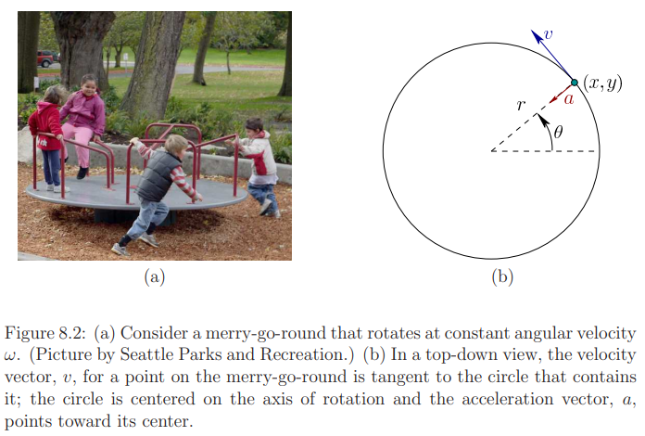
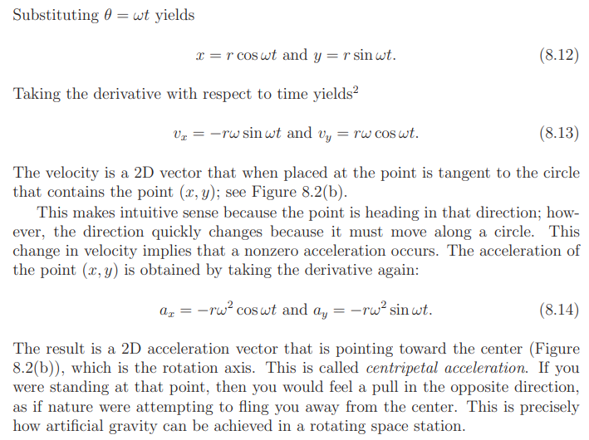
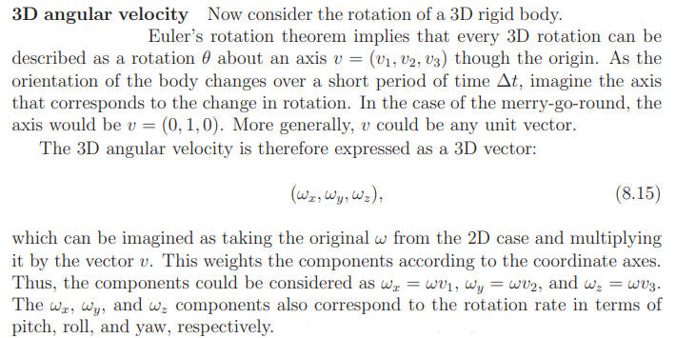
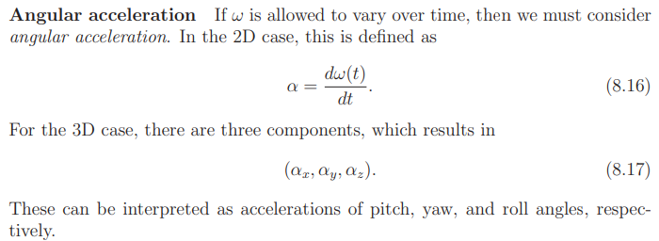
- The Vestibular System
- Located in the inner ear; responsible for body’s equilibrium.
- Creates sense of balance and spatial orientation.
- The balance sense (or vestibular sense) provides information to the brain about how the head is oriented or how it is moving in general.
- This is accomplished through vestibular organs that measure both linear and angular accelerations of the head.
- These organs, together with their associated neural pathways, will be referred to as the vestibular system.
- This system plays a crucial role for bodily functions that involve motion, from ordinary activity such as walking or running, to activities that require substantial talent and training, such as gymnastics or ballet dancing.
The vestibular system is important to VR because it is usually neglected, which leads to a mismatch of perceptual cues. In current VR systems, there is no engineered device that renders vestibular signals to a display that precisely stimulates the vestibular organs to values as desired. Some possibilities may exist in the future with galvanic vestibular stimulation, which provides electrical stimulation to the organ; however, it may take many years before such techniques are sufficiently accurate, comfortable, and generally approved for safe use by the masses.
Physiology
Figure 8.4 shows the location of the vestibular organs inside of the human head. As in the cases of eyes and ears, there are two symmetric organs, corresponding to the right and left sides. Figure 8.3 shows the physiology of each vestibular organ.
The cochlea handles hearing, and the remaining parts belong to the vestibular system. The utricle and saccule measure linear acceleration; together they form the otolith system. When the head is not tilted, the sensing surface of the utricle mostly lies in the horizontal plane (or xz plane in our common coordinate systems), whereas the corresponding surface of the saccule lies in a vertical plane that is aligned in the forward direction (this is called the sagittal plane, or yz plane).
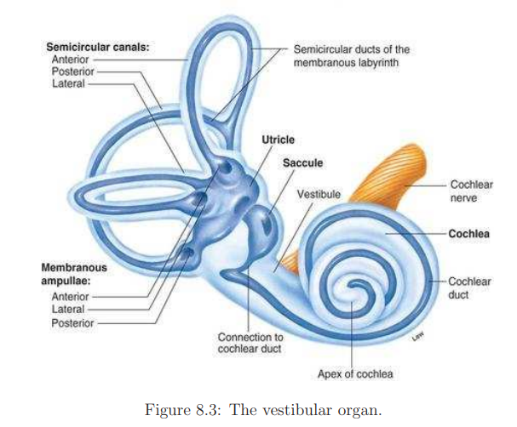
The utricle senses acceleration components a_{x} and a_{z}, and the saccule senses a_{y} and a_{z} (a_{z} is redundantly sensed).
The semicircular canals measure angular acceleration. Each canal has a diameter of about 0.2 to 0.3mm, and is bent along a circular arc with a diameter of about 2 to 3mm. The three canals are roughly perpendicular so that they independently measure three components of angular velocity. The particular canal names are anterior canal, posterior canal, and lateral canal. They are not closely aligned with our usual 3D coordinate axes. Note from Figure 8.4 that each set of canals is rotated by 45 degrees with respect to the vertical axis. Thus, the anterior canal of the left ear aligns with the posterior canal of the right ear. Likewise, the posterior canal of the left ear aligns with the anterior canal of the right ear. Although not visible in the figure, the lateral canal is also tilted about 30 away from level. 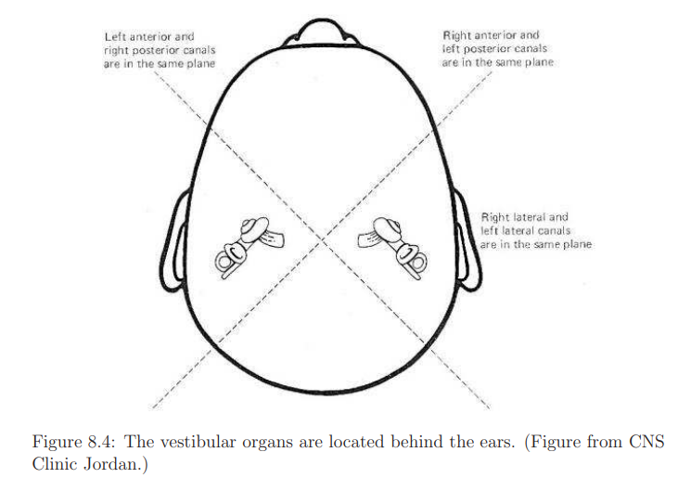
Sensing linear acceleration
Figure 8.5 shows a schematic representation of an otolith organ, which may be either the utricle or saccule. Mechanoreceptors, in the form of hair cells, convert acceleration into neural signals. Each hair cell has cilia.
The cilia of saccule and utricle are embedded in a gel-like layer sprinkled with calcium carbonate crystals called otoconia(ear rocks). The crystals add weight to the layer , pulling it down with gravity. When the head is in upright position , the gelatinous layer bears down evenly on the cells of the utricle, the cilia remain straight and no signals are generated. On the vertical saccule, however the heavy gel is pulled down by gravity at one end, bending the cilia generating nerve impulses. The reverse is true when the head is horizontal.
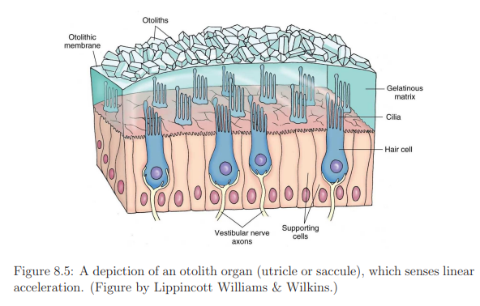
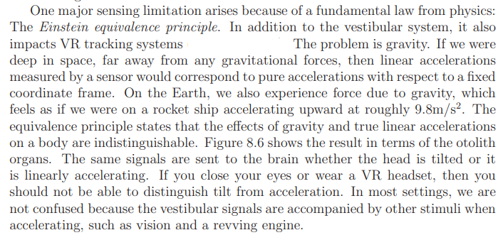
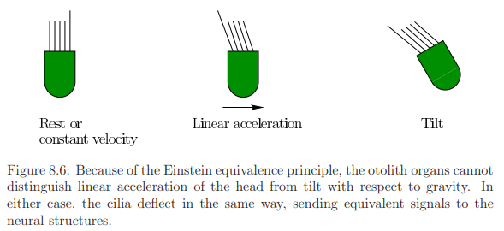
At the heart of Einstein's theory of gravity (general relativity) is the equivalence principle. The equivalence principle says that there is no difference between being stationary and subject to gravity tugging you and accelerating in a vehicle that's free of gravitational pull.
Sensing angular acceleration
Semicircular canals contain a fluid called endolymph. Each semicircular canals has an enlargement at one end called an ampulla. Within ampulla there are hair cells embedded in a gel-like structure called cupula. When the head turns, the ducts that are located on the same plane of motion rotate, but the fluid lag behinds because of inertia. This cause the fluid to briefly move in the opposite direction as the head and either push or pull on the cupula bending the cilia on the hair cells and thus activate them to send nerve impulses to the brain. The direction of the bend determines if the signals generated are excitatory(bending towards tallest cilium) or inhibitory (bending away from the tallest cilium). Because the two sides of the head are mirror images, a head turn generates excitatory signals on one side and inhibitory signals on the other.
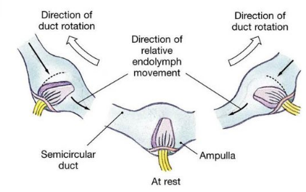
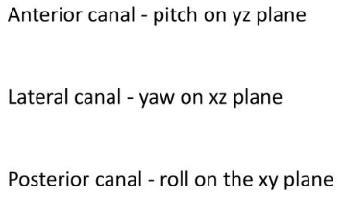
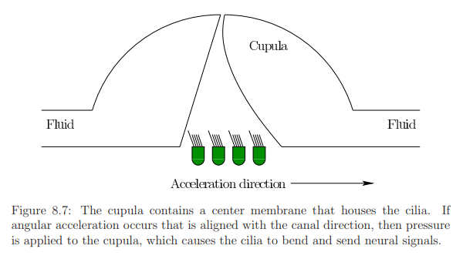
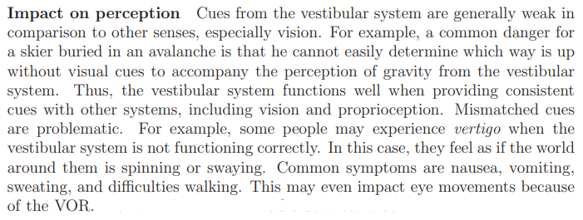
- Physics in the Virtual World
3.1 Tailoring the Physics to the Experience
If we expect to fool our brains into believing that we inhabit the virtual world, then many of our expectations from the real world should be matched in the virtual world.
The VWG contains a physics engine that governs the motions of bodies in the virtual world by following principles from the physical world. Forces acting on bodies, gravity, fluid flows, and collisions between bodies should be handled in perceptually convincing ways. Physics engines arise throughout engineering and physics in the context of any simulation. In video games, computer graphics, and film, these engines perform operations that are very close to our needs for VR. This is why popular game engines such as Unity 3D and Unreal Engine have been quickly adapted for use in VR.
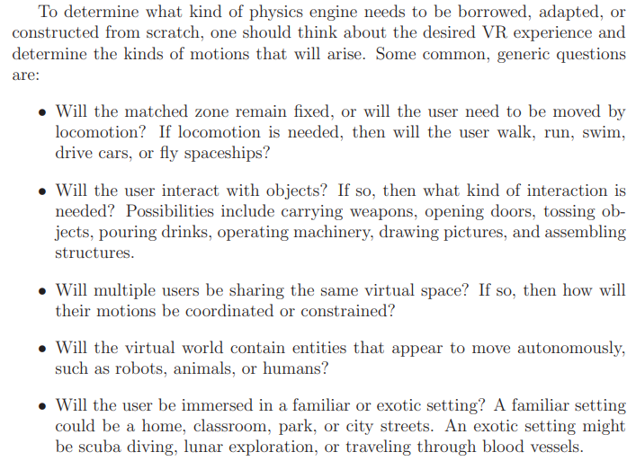

Based on the answers to the questions above, the physics engine design may be simple and efficient, or completely overwhelming. A key challenge is to keep the virtual world frequently updated so that interactions between users and objects are well synchronized and renderers provide a low-latency projection onto displays.
  - Numerical simulation
The state of the virtual world
Imagine a virtual world that contains many moving rigid bodies. For each body, think about its degrees of freedom (DOFs), which corresponds to the number of independent parameters needed to uniquely determine its position and orientation. We would like to know the complete list of parameters needed to put every body in its proper place in a single time instant. A specification of values for all of these parameters is defined as the state of the virtual world.
The job of the physics engine can then be described as calculating the virtual world state for every time instant or “snapshot” of the virtual world that would be needed by a rendering system. Once the state is determined, the mathematical transforms are used to place the bodies correctly in the world and calculate how they should appear on displays.
Degrees of freedom
How many parameters are there in a virtual world model?
A free-floating body has 6 DOFs which implies 6 parameters to place it anywhere. In many cases, DOFs are lost due to constraints. For example, a ball that rolls on the ground has only 5 DOFs because it can achieve any 2D position along the ground and also have any 3D orientation.
It might be sufficient to describe a car with 3 DOFs by specifying the position along the ground (two parameters) and the direction it is facing (one parameter); see Figure 8.8(a). However, if the car is allowed to fly through the air while performing stunts or crashing, then all 6 DOFs are needed.
For many models, rigid bodies are attached together in a way that allows relative motions. This is called multibody kinematics. (The multibody dynamics (MBD) generally refers the study of mechanical systems that consist of a set of rigid bodies and links connected each other by joints to restrict their relative motion).For example, a car usually has 4 wheels which can roll to provide one rotational DOF per wheel . Furthermore, the front wheels can be steered to provide an additional DOF. Steering usually turns the front wheels in unison, which implies that one DOF is sufficient to describe both wheels. If the car has a complicated suspension system, then it cannot be treated as a single rigid body, which would add many more DOFs.
Similarly, an animated character can be made by attaching rigid bodies to form a skeleton; see Figure 8.8(b). Each rigid body in the skeleton is attached to one or more other bodies by a joint. For example, a simple human character can be formed by attaching arms, legs, and a neck to a rigid torso. The upper left arm is attached to the torso by a shoulder joint. The lower part of the arm is attached by an elbow joint, and so on. Some joints allow more DOFs than others. For example, the shoulder joint has 3 DOFs because it can yaw, pitch, and roll with respect to the torso, but an elbow joint has only one DOF.
To fully model the flexibility of the human body, 244 DOFs are needed, which are controlled by 630 muscles. In many settings, this would be too much detail, which might lead to high computational complexity and difficult implementation. Also more realism might lead to increased perceived creepiness of the character. Thus, having more DOFs is not clearly better, and it is up to a VR content creator to determine how much mobility is needed to bring a character to life, in a way that is compelling for a targeted purpose.
In the extreme case, rigid bodies are not sufficient to model the world. We might want to see waves rippling realistically across a lake, or hair gently flowing in the breeze. In these general settings, nonrigid models are used, in which case the state can be considered as a continuous function. For example, a function of the form y = f(x, z) could describe the surface of the water. The result could effectively be an infinite number of DOFs. Motions in this setting are typically described using partial differential equations (PDEs), which are integrated numerically to obtain the state at a desired time. Usually, the computational cost is high enough to prohibit their use in interactive VR experiences.
Differential equations
We now introduce some basic differential equations to model motions. The resulting description is often called a dynamical system. The first step is to describe rigid body velocities in terms of state. Returning to models that involve one or more rigid bodies, the state corresponds to a finite number of parameters. Let
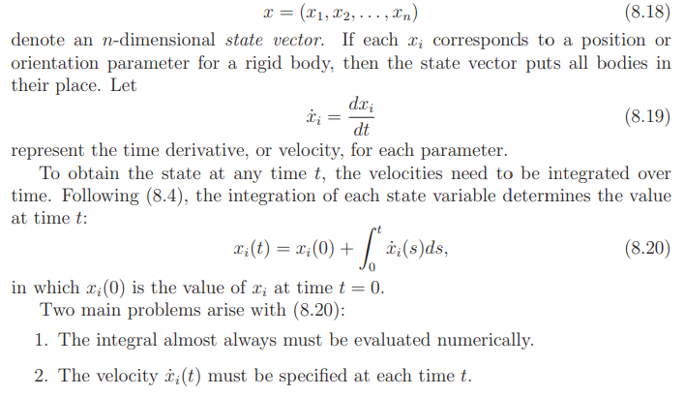
Runge-kutta integration
Refer Note

  - Collision Detection
- Key challenge in physics engine: handling collisions
- Collision detection algorithms are plentiful because of widespread use in computer graphics and video games
Solid or boundary model?
Figure 8.10 shows one the first difficulties with collision detection, in terms of two triangles in a 2D world. The first two cases (Figures 8.10(a) and 8.10(b)) show obvious cases; however, the third case, Figure 8.10(c), could be ambiguous. If one triangle is wholly inside of another, then is this a collision? If we interpret the outer triangle as a solid model, then yes. If the outer triangle is only the boundary edges, and is meant to have an empty interior, then the answer is no.
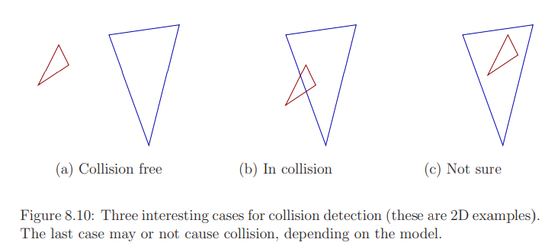
Distance functions
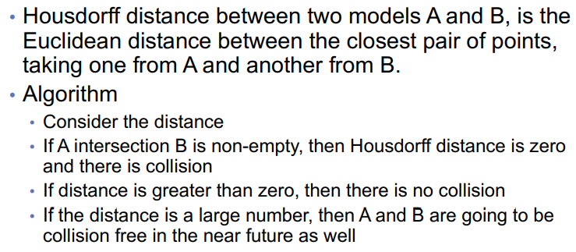
A concept related to distance is penetration depth, which indicates how far one model is poking into another . This is useful for setting a threshold on how much interference between the two bodies is allowed. For example, the user might be able to poke his head two centimeters into a wall, but beyond that, an action should be taken.
Simple collision tests
At the lowest level, collision detection usually requires testing a pair of model primitives to determine whether they intersect. In the case of models formed from 3D triangles, then we need a method that determines whether two triangles intersect.
Broad and narrow phases
Suppose that a virtual world has been defined with millions of triangles. If two complicated, nonconvex bodies are to be checked for collision, then the computational cost may be high. For this complicated situation, collision detection often becomes a two-phase process:
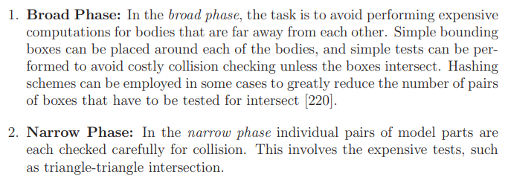
In the broad phase, hierarchical methods generally decompose each body into a tree. Each vertex in the tree represents a bounding region that contains some subset of the body. The bounding region of the root vertex contains the whole body.
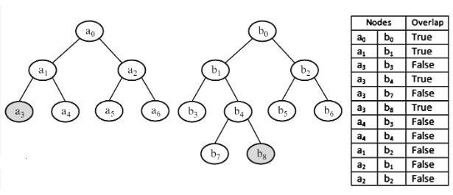
Two opposing criteria that guide the selection of the type of bounding region:
1. The region should fit the intended model points as tightly as possible.
2. The intersection test for two regions should be as efficient as possible.
Several popular choices are shown in Figure 8.11, for the case of an L-shaped body.
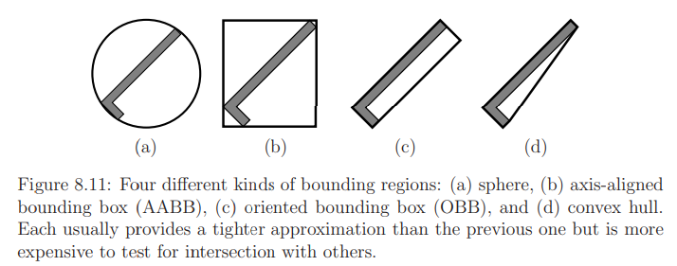
The tree is constructed for a body, A (or alternatively, B) recursively as follows.
- For each vertex, consider the set X of all points in A that are contained in the bounding region.
- Two child vertices are constructed by defining two smaller bounding regions whose union covers X. The split is made so that the portion covered by each child is of similar size. If the geometric model consists of primitives such as triangles, then a split could be made to separate the triangles into two sets of roughly the same number of triangles.
- A bounding region is then computed for each of the children.
- Figure 8.12 shows an example of a split for the case of an L-shaped body.
- Children are generated recursively by making splits until very simple sets are obtained. For example, in the case of triangles in space, a split is made unless the vertex represents a single triangle. In this case, it is easy to test for the intersection of two triangles.
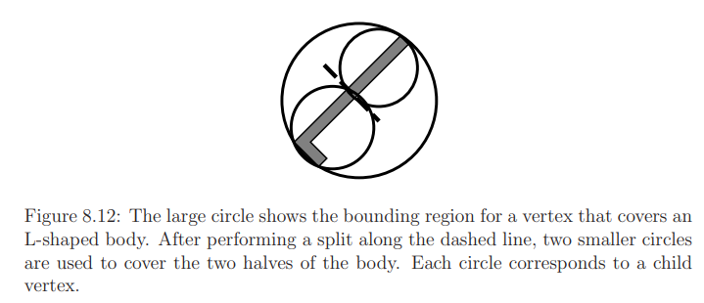
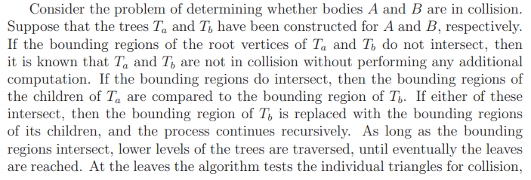
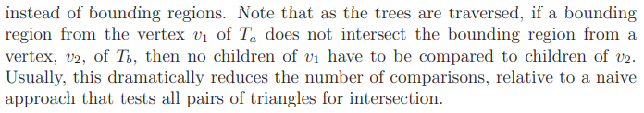
Mismatched obstacles in VR
• Collision detection in VR has applications applied to mismatches between real and virtual worlds.
- Real obstacle only:
- In this case, an obstacle exists in the real world, but not in the virtual world.
- This is potentially dangerous! For example, you could move your arm and knock over a real, hot cup of coffee that is not represented in the virtual world.
- If you were walking with a VR headset, then imagine what would happen if a set of real downward stairs were not represented.
- Solution: At the very least, the boundary of the matched zone should be rendered if the user gets close to it.
- Solution: real objects that block user can be rendered on display.
- This mismatch motivated the introduction of the Chaperone system in the HTC Vive headset, in which an outward-facing camera is used to detect and render real objects that may obstruct user motion.
- Virtual obstacle only:
- This case is not dangerous, but can be extremely frustrating.
- Eg: A wall in the virtual world not present in the real world (frustrating).
- The user could poke her head through a wall in VR without feeling any response in the real world. This should not be allowed in most cases.
- The VWG could simply stop moving the viewpoint in the virtual world as the virtual wall is contacted; however, this generates a mismatch between the real and virtual motions, which could be uncomfortable for the user.
- It remains a difficult challenge to keep users comfortable while trying to guide them away from interference with virtual obstacles.
- Real and virtual obstacle:
- If obstacles are matched in both real and virtual worlds, then the effect is perceptually powerful.
- For example, you might stand on a slightly raised platform in the real world while the virtual world shows you standing on a building rooftop. If the roof and platform edges align perfectly, then you could feel the edge with your feet. Would you be afraid to step over the edge? A simpler case is to render a virtual chair that matches the real chair that a user might be sitting in.
- Mismatched Motion and Vection
Vection is an illusion of self motion that is caused by varying visual stimuli. In other words, the brain is tricked into believing that the head is moving based on what is seen, even though no motion actually occurs.
Vection is also commonly induced in VR by moving the user’s viewpoint while there is no corresponding motion in the real world. Vection is a prime example of mismatched cues. Vection unfortunately leads many people to experience sickness symptoms, such as dizziness, nausea, and occasionally even vomiting. Thus, it should be used very cautiously.
Industry leaders often proclaim that their latest VR headset has beaten the VR sickness problem; however, this neglects the following counterintuitive behavior:
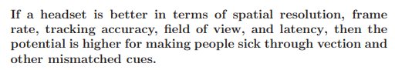
Put simply, if the headset more accurately mimics reality, then the sensory cues are stronger, and our perceptual systems become more confident about mismatched cues.
In some cases, the mismatch of cues may be harmless (although possibly leading to a decreased sense of presence). In other cases, the mismatches may lead to greater fatigue as the brain works harder to resolve minor conflicts.
Optical Flow
The human visual system has neural structures dedicated to detecting the motion of visual features in the field of view.
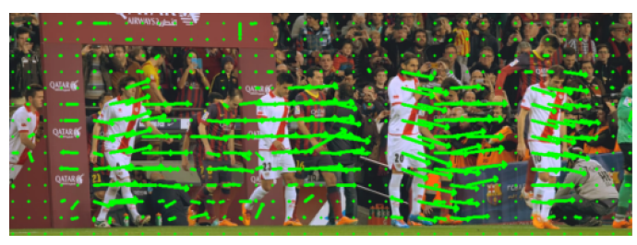
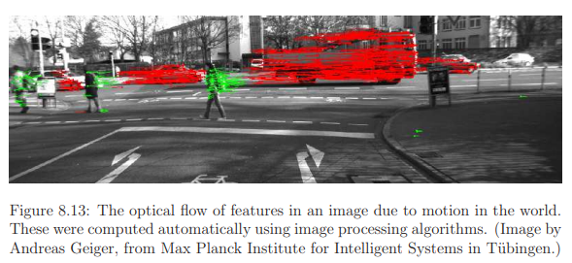
See Fig:8.13. Optical flow is the pattern of apparent motion of objects in a visual scene.
• Motion of visual features on the retina/display is modelled as a vector field.
There are certain problems in applied mathematics(eg: fluid flow) where it is natural to consider a vector attached to each point in a given region. Such a collection of vectors is called a vector field.
We therefore define a vector field, which assigns a velocity vector at every point along a surface. If the surface is the xy plane, then a velocity vector
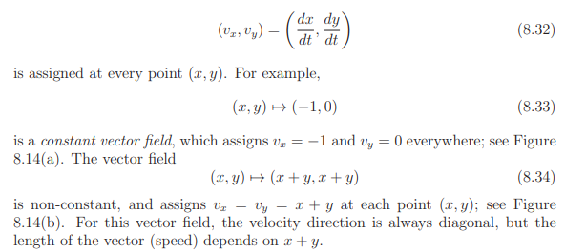
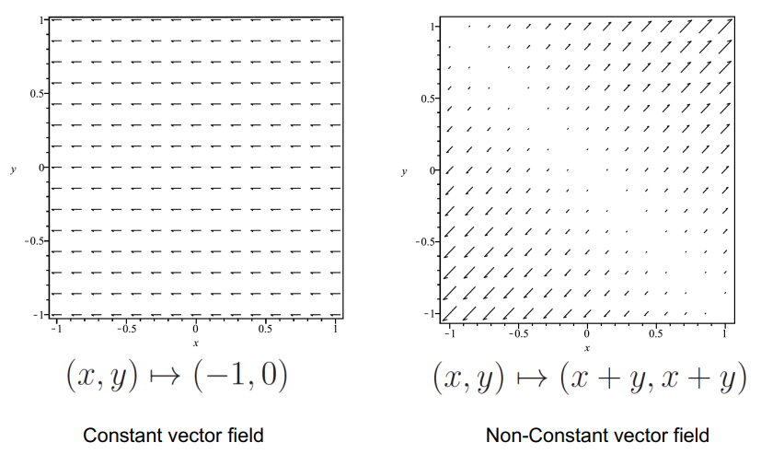
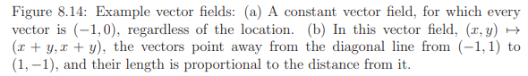
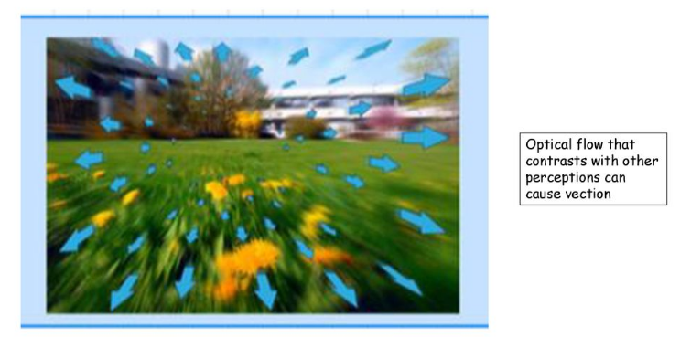
Types of Vection
- Vection can be caused by any combination of angular and linear velocities of the viewpoint in the virtual world.
- Viewpoint velocities are commonly divided into three linear components: v_{x}, v_{y}, and v_{z}, and three angular components, ω_{x}, ω_{y}, and ω_{z}.
- Therefore, we consider the optical flow for each of these six cases (see Figure 8.15):
(To most accurately describe the motion of features along the retina, the vector field should be defined over a spherical surface that corresponds to the locations of the photoreceptors. Instead, we will describe vector fields over a square region, with the understanding that it should be transformed onto a sphere for greater accuracy.)
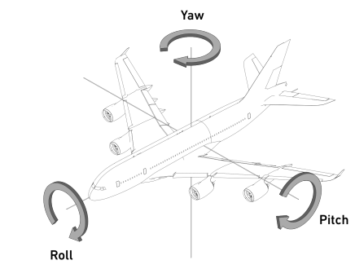
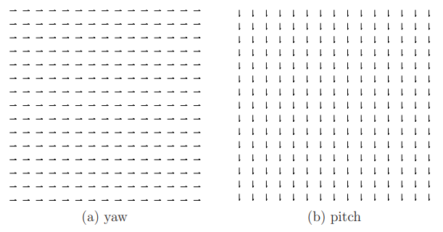
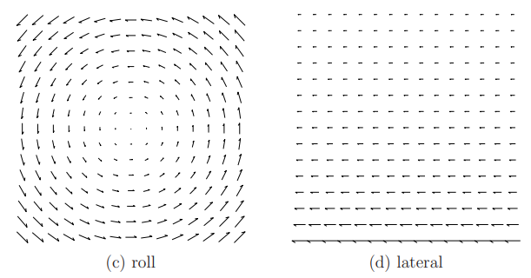
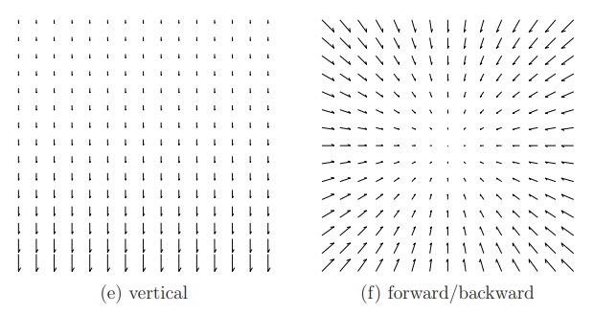
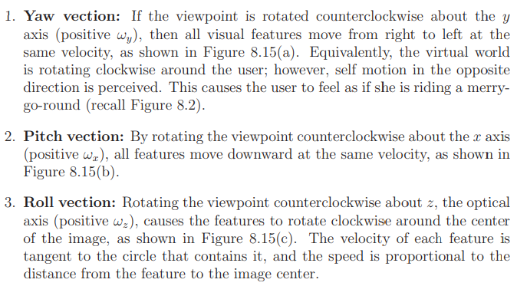
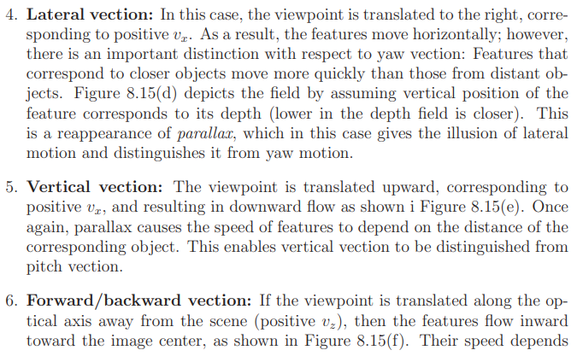
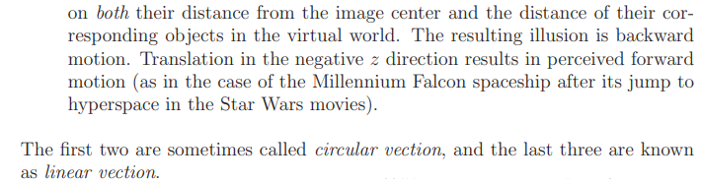
- All forms of vection cause perceived velocity
- If there is a change in velocity, it may cause perceived acceleration
Vestibular mismatch
Visual Vestibular Mismatch, is a conflict in your brain where the visual information coming from your eyes does not match the vestibular information coming from your ears. Think of that feeling you get when you’re watching the latest blockbuster movie and the only seats left were in the front row - sometimes, you’re not sure if it’s you or the screen that’s moving. That nauseous, unsteady, motion sick-like, gross feeling is a direct result of the VVM experienced in that moment.
Factors that affect sensitivity
The intensity of vection is affected by many factors:
• Percentage of field of view: If only a small part of the visual field is moving, then people tend to perceive that it is caused by a moving object. However, if most of the visual field is moving, then they perceive themselves as moving. The human visual system actually includes neurons with receptive fields that cover a large fraction of the retina for the purpose of detecting self motion .As VR headsets have increased their field of view, they project onto a larger region of the retina, thereby strengthening vection cues.
• Distance from center view: The photoreceptors are not uniformly distributed, with the highest density being at the innermost part of the fovea. Thus, detection may seem stronger near the center. However, in the cases of yaw and forward/backward vection, the optical flow vectors are stronger at the periphery, which indicates that detection may be stronger at the periphery. Sensitivity to the optical flow may therefore be strongest somewhere between the center view and the periphery, depending on the viewpoint velocities, distances to objects, photoreceptor densities, and neural detection mechanisms.
• Exposure time: The perception of self motion due to vection increases with the time of exposure to the optical flow. If the period of exposure is very brief, such as a few milliseconds, then no vection may occur.
• Spatial frequency: If the virtual world is complicated, with many small structures or textures, then the number of visual features will be greatly increased and the optical flow becomes a stronger signal. As the VR headset display resolution increases, higher spatial frequencies can be generated.
• Contrast: With higher levels of contrast, the optical flow signal is stronger because the features are more readily detected. Therefore, vection typically occurs with greater intensity.
• Other sensory cues: A perceptual phenomenon depends on the combination of many cues. Vection can be enhanced by providing additional consistent cues. For example, forward vection could be accompanied by a fan blowing in the user’s face, a rumbling engine, and the sounds of stationary objects in the virtual world racing by. Likewise, vection can be weakened by providing cues that are consistent with the real world, where no corresponding motion is occurring.
• Prior knowledge: Just by knowing beforehand what kind of motion should be perceived will affect the onset of vection. This induces a prior bias that might take longer to overcome if the bias is against self motion, but less time to overcome if it is consistent with self motion. The prior bias could be from someone telling the user what is going to happen, or it could simply by from an accumulation of similar visual experiences through the user’s lifetime. Furthermore, the user might expect the motion as the result of an action taken, such as turning the steering wheel of a virtual car.
• Attention: If the user is distracted by another activity, such as aiming a virtual weapon or selecting a menu option, then vection and its side effects may be mitigated.
• Prior training or adaptation: With enough exposure, the body may learn to distinguish vection from true motion to the point that vection becomes comfortable. Thus, many users can be trained to overcome VR sickness through repeated, prolonged exposure.

QUESTIONS
- Explain how collision detection happens in the world of motion. (3 marks)
- Differentiate motions in the real and virtual world?(3 marks)
Answer
The physics of both real and virtual worlds impact VR experiences. The accelerations and velocities of moving bodies impact simulations in the VWG and tracking methods used to capture user motions in the physical world.
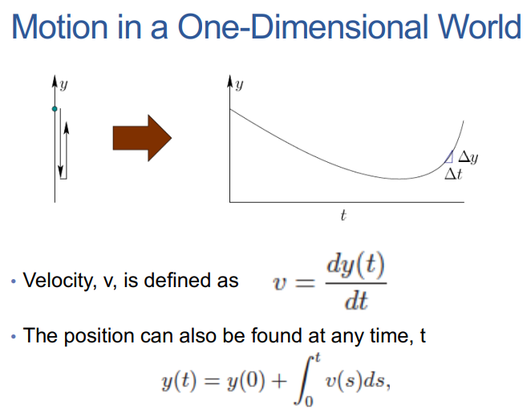
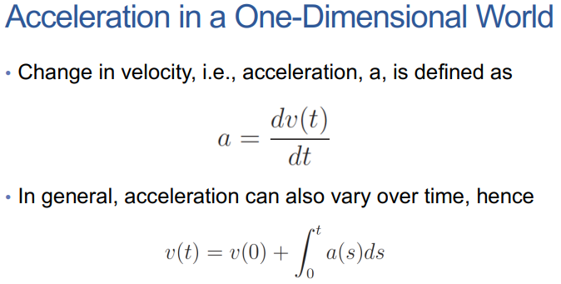
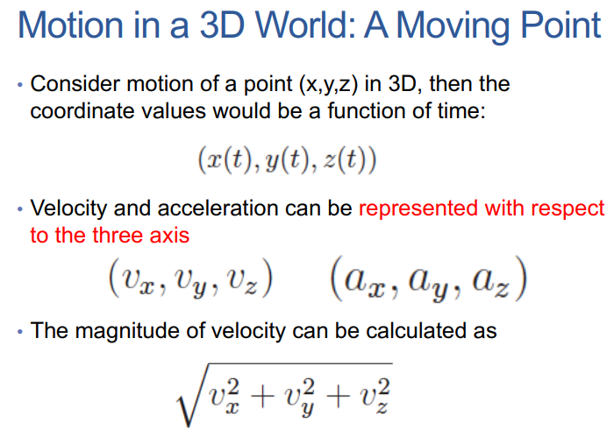

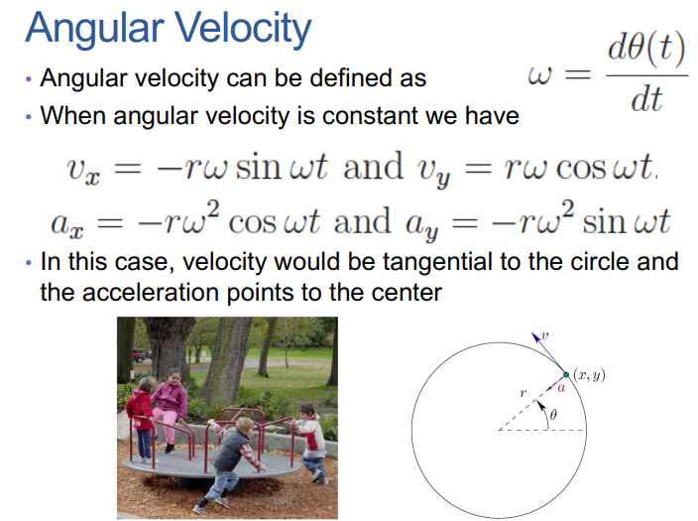

- Explain about the vestibular system(3 marks) or (14 marks)
- Explain about mismatched Motion and Vection? (14 marks)
- Which are the types of vection? (8 marks)
- Which are the factors that affect vection? (3 marks) or (7 marks)

Answer
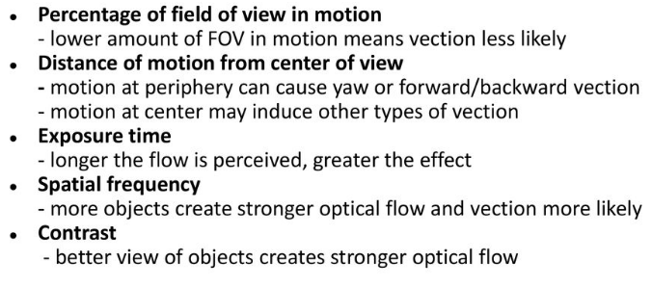
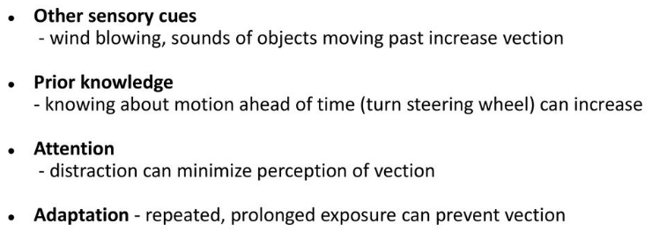
7.
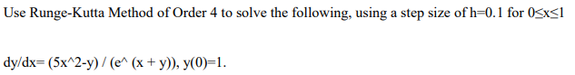
- marks)
8.Explain in detail how is collision detected in a physics engine.(14 marks)

